- Problem Statement : Word Count program using MapReduce

Step1:goto Search button run cmd prompt as administrator
Step2: Initiate all required component of hadoop by command
start-all.cmd
Step3: Create a text file where we have folder running hadoop java program in my case I have created in Desktop
U can create anywhere as u wish
Step4: Create a Directory in HDFS console using command
hadoop fs -mkdir /textformat
Where textform is ur input directory
Step5: We have to add text into a directory<textformat> in my case b.txt is in desktop folder copy the path and type command
hadoop fs -put C:\Users\User\Desktop\b.txt /textformat
After completion of above command u be able to see b.txt in /textformat directory of hdfs console
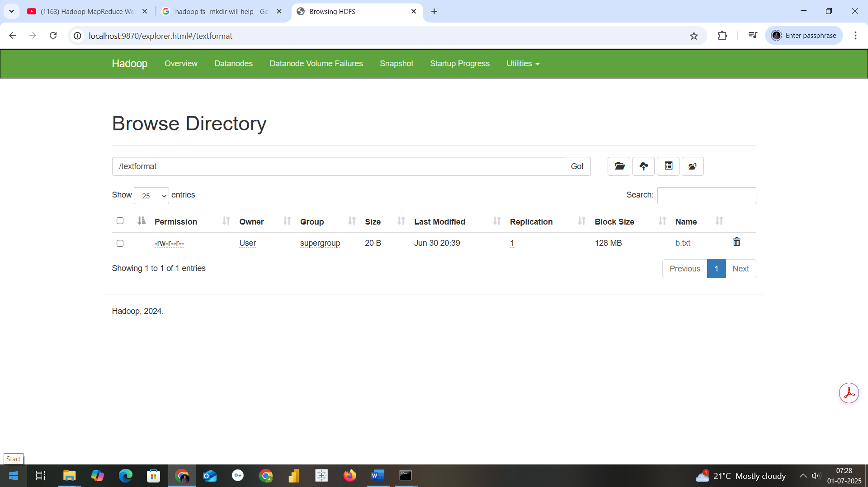
In cmd prmpt if u want to check type the command as
hadoop fs -ls /textformat

Step6: Now we need a jar file to execute mapreduce program fr wordcount
So open Eclipse
Create a java project with name MapReduceWordCount
Select execution environment as JavaSE-1.8
And click on next&finish

Step7: Right Click on Projectname--- Click on New---create a package with name com.mapreduce.wc and click on Finish
Step8: Add required libraries to support hadoop by navigating as in below
Right Click on Project-------Right Click on BuildPath------- Configure Buildpath Then goto Libraries as in second screen below
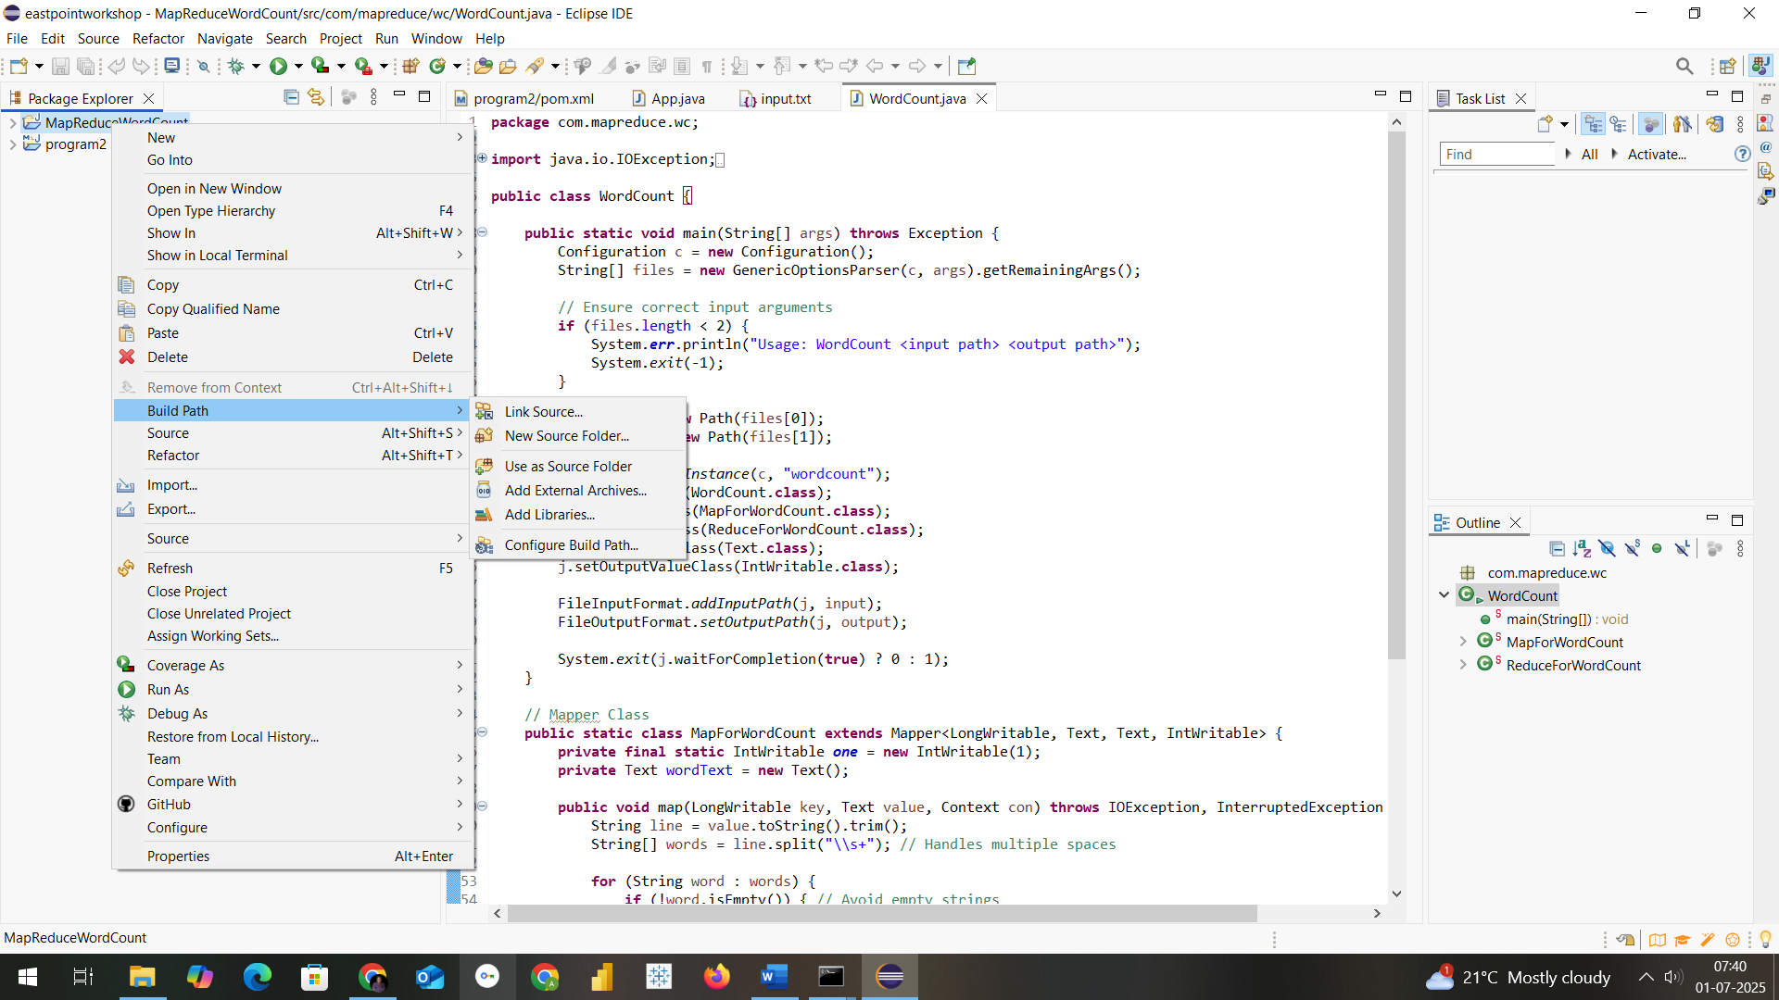

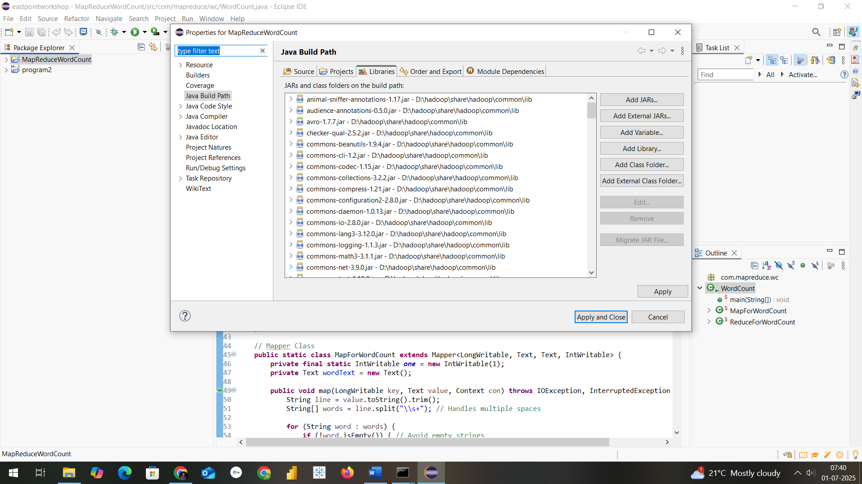
Step9: Add necessary External jar file from D:\hadoop\share\hadoop
Like clients,common,hdfs,mapreduce & yarn to support packages for hadoop
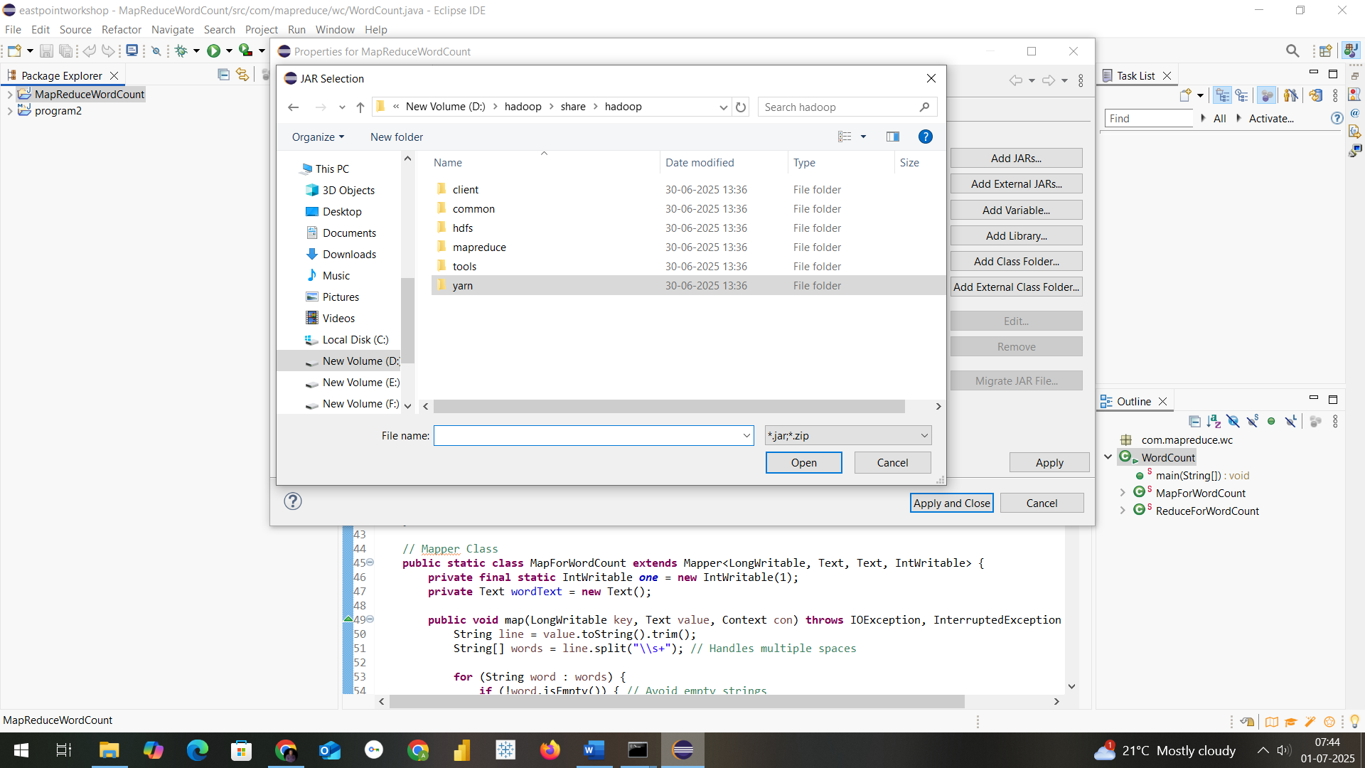

Step10: Create aclass within package com.mapreduce.wc with name WordCount and paste this code
package com.mapreduce.wc;

import java.io.IOException;
import org.apache.hadoop.conf.Configuration;
import org.apache.hadoop.fs.Path;
import org.apache.hadoop.io.IntWritable;
import org.apache.hadoop.io.LongWritable;
import org.apache.hadoop.io.Text;
import org.apache.hadoop.mapreduce.Job;
import org.apache.hadoop.mapreduce.Mapper;
import org.apache.hadoop.mapreduce.Reducer;
import org.apache.hadoop.mapreduce.lib.input.FileInputFormat;
import org.apache.hadoop.mapreduce.lib.output.FileOutputFormat;
import org.apache.hadoop.util.GenericOptionsParser;

public class WordCount {

public static void main(String[] args) throws Exception {
Configuration c = new Configuration();
String[] files = new GenericOptionsParser(c, args).getRemainingArgs();

// Ensure correct input arguments
if (files.length < 2) {
System.err.println("Usage: WordCount <input path> <output path>");
System.exit(-1);
}

Path input = new Path(files[0]);
Path output = new Path(files[1]);

Job j = Job.getInstance(c, "wordcount");
j.setJarByClass(WordCount.class);
j.setMapperClass(MapForWordCount.class);
j.setReducerClass(ReduceForWordCount.class);
j.setOutputKeyClass(Text.class);
j.setOutputValueClass(IntWritable.class);

FileInputFormat.addInputPath(j, input);
FileOutputFormat.setOutputPath(j, output);

System.exit(j.waitForCompletion(true) ? 0 : 1);
}

// Mapper Class
public static class MapForWordCount extends Mapper<LongWritable, Text, Text, IntWritable> {
private final static IntWritable one = new IntWritable(1);
private Text wordText = new Text();

public void map(LongWritable key, Text value, Context con) throws IOException, InterruptedException {
String line = value.toString().trim();
String[] words = line.split("\\s+"); // Handles multiple spaces

for (String word : words) {
if (!word.isEmpty()) { // Avoid empty strings
wordText.set(word.trim().toUpperCase());
con.write(wordText, one);
}
}
}
}

// Reducer Class
public static class ReduceForWordCount extends Reducer<Text, IntWritable, Text, IntWritable> {
public void reduce(Text word, Iterable<IntWritable> values, Context con) throws IOException, InterruptedException {
int sum = 0;
for (IntWritable value : values) {
sum += value.get();
}
con.write(word, new IntWritable(sum));
}
}
}

Step11: Procedure to create jar file from eclipse project
Now Right click on Project and click on export and select jar as in screen
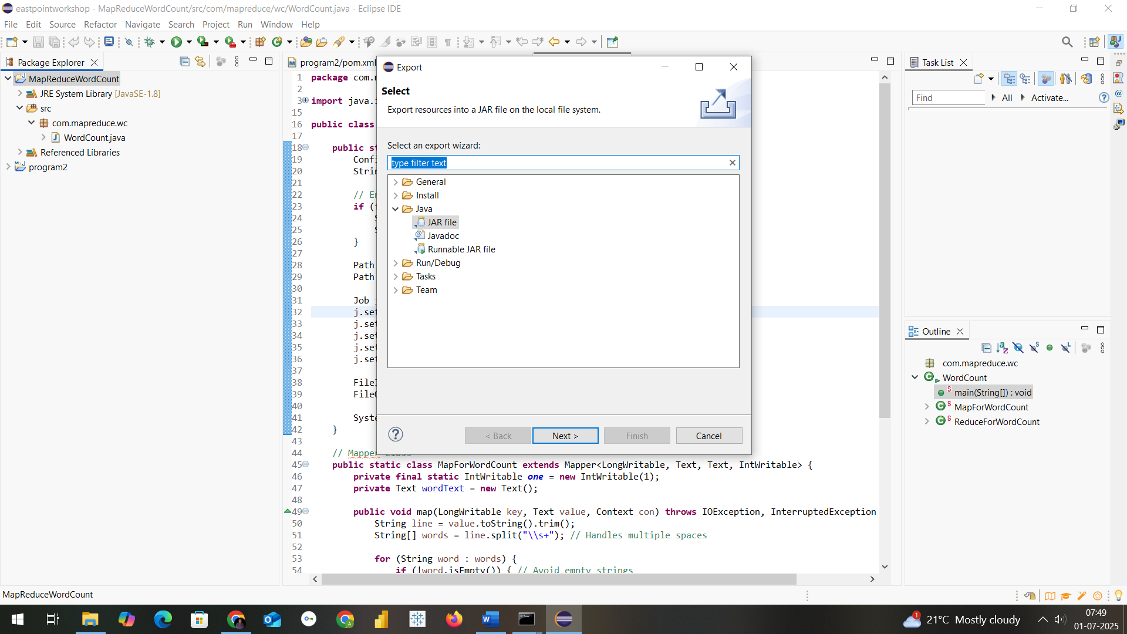
Mention the path where u want to save jar with name of Jar File in my case I have saved in D:\hadoopprograms as WordCountMapReduce

Final step: Run the jar file with command as in below
hadoop jar D:\hadoopprograms\WordCountMapReduce.jar com.mapreduce.wc/WordCount /textformat/b.txt /outformat
THE OUTFORMAT WILL BE CREATED IN CONSOLE
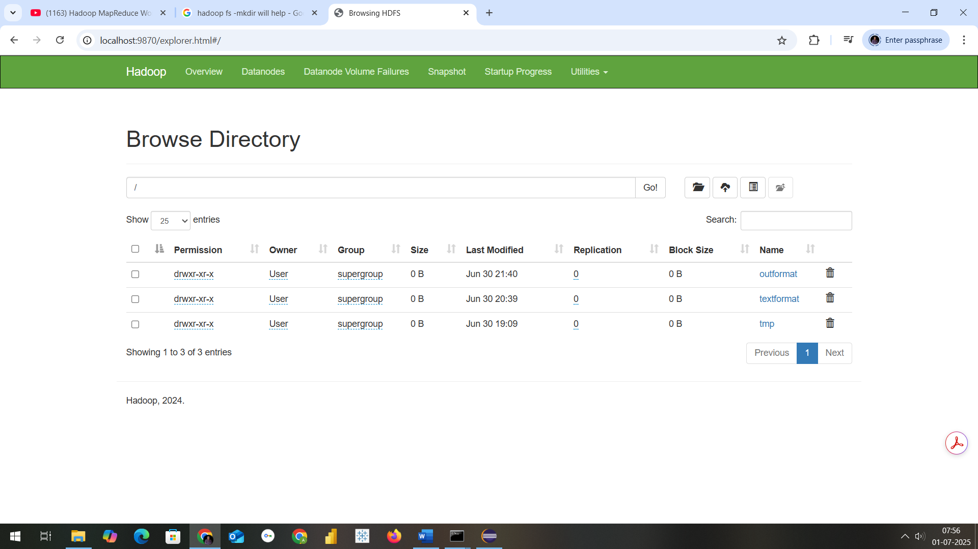

NOW TO CHECK THE RESULT OF WEATHER PROGRAM IS CORRECT TYPE
hadoop fs -cat /outformat/*
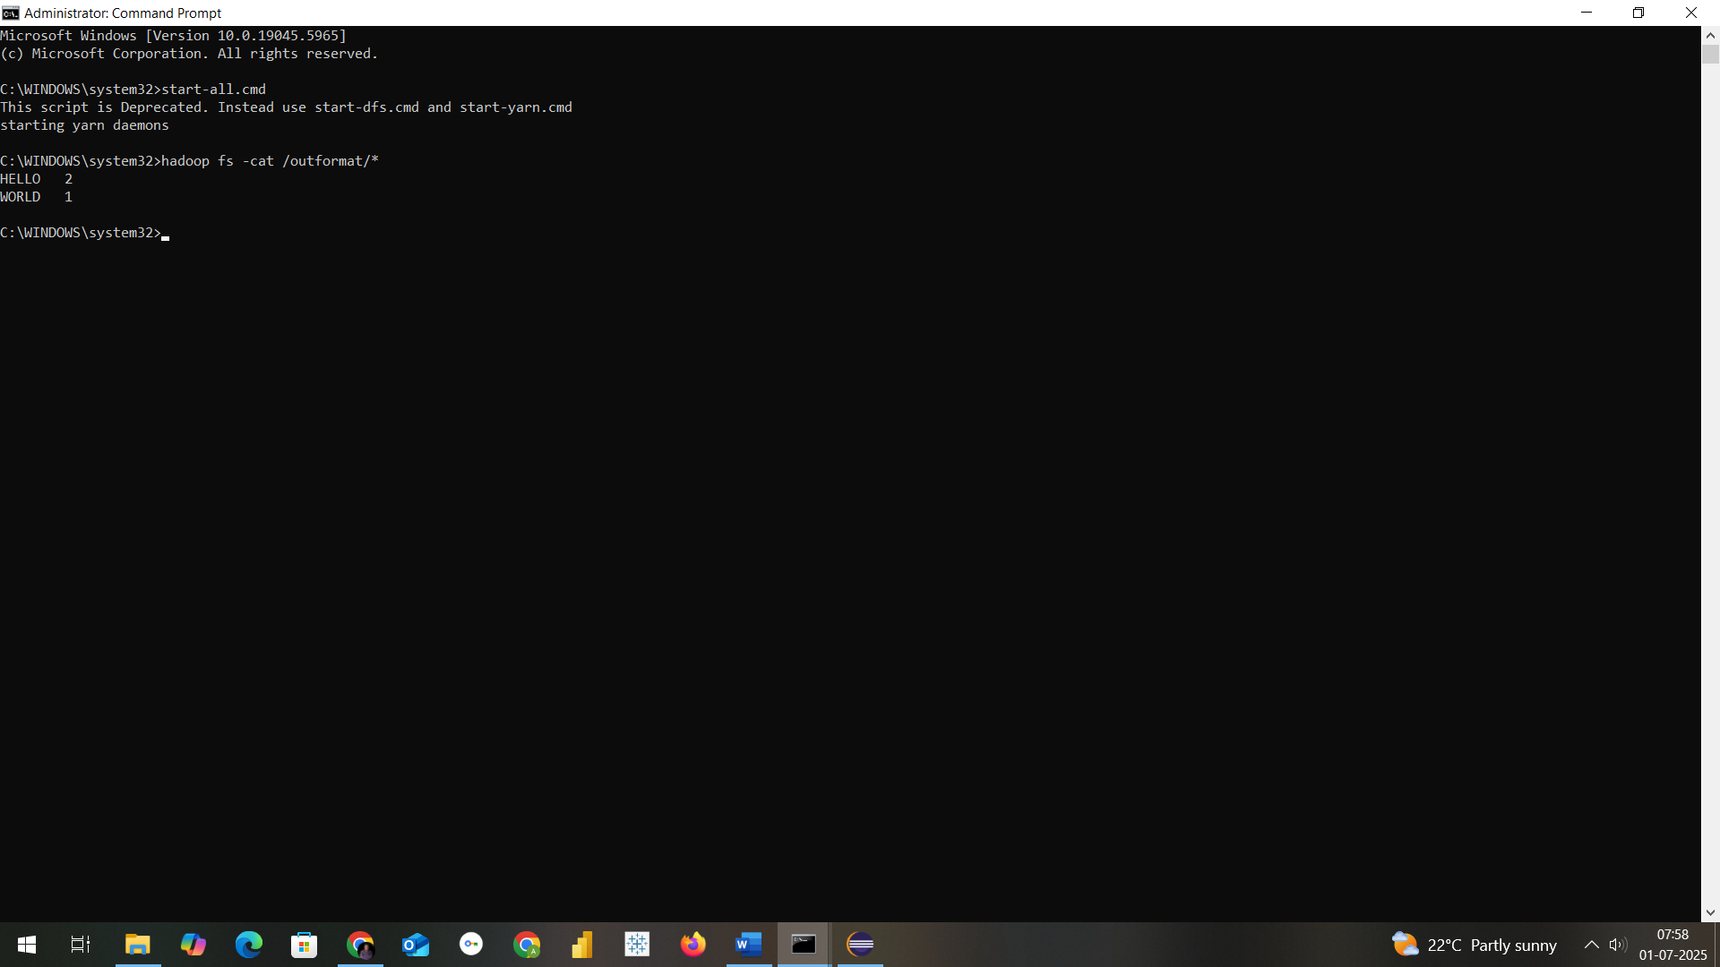
AS YOU CAN SEE HELLO IS 2 in count and WORLD to 1 as my textformat(b.txt) is
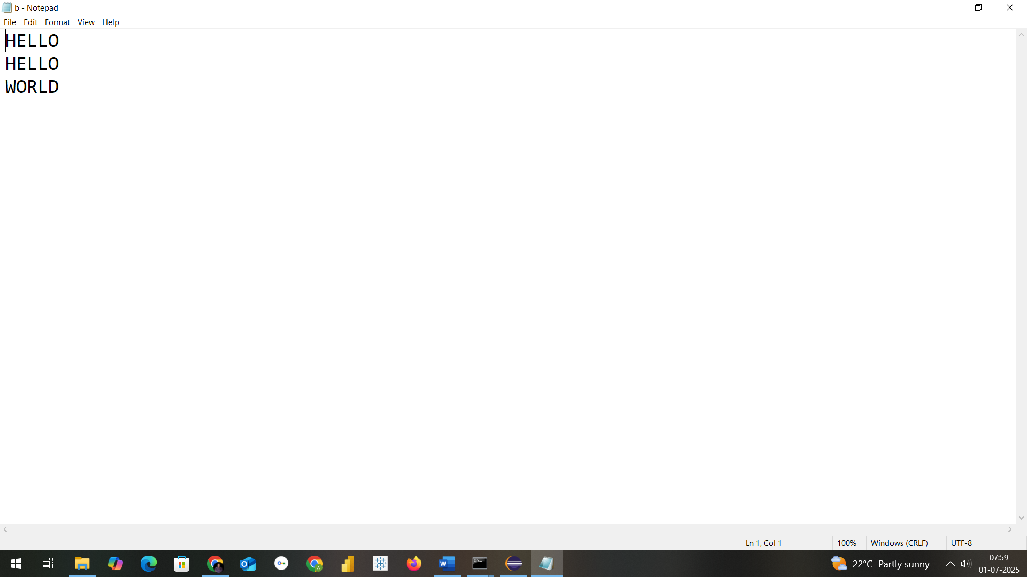

Thank You

